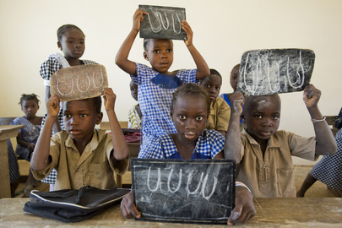
Young students hold up their chalkboards in a school rehabilitated by the UN Operation in Côte d'Ivoire (UNOCI), as part of its “quick impact projects” (QIPS), in Duékoué.
20 December 2011
Duékoué, Côte d'Ivoire

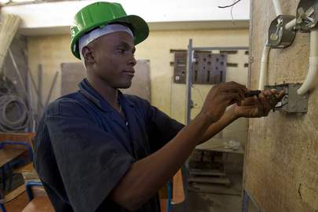
Students learn electrical wiring at the SOS Training Center in Cap-Haïtien, Haiti. The United Nations Stabilization Mission in Haiti (MINUSTAH)’s Community Violence Reduction section developed and implemented a training programme for youth that focuses on mechanics, electrical, building, plumbing, tailoring, and cosmetology, in a drive to reduce community violence by offering young people from disenfranchised neighbourhoods the skills to find employment.
21 November 2011
Cap-Haïtien, Haiti

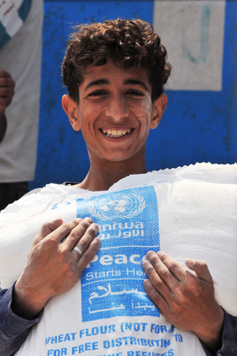
A young Palestinian refugee receives a sack of flour at one of the food distribution operated by the UN Relief and Works Agency for Palestine Refugees in the Near East (UNRWA). The Agency provides food aid to approximately one million Palestinian refugees in the Gaza Strip.
02 June 2011
Gaza

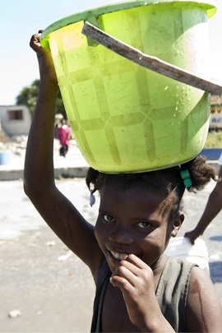
A girl in the shanty town of Cité Soleil, Haiti, near Port-au-Prince, smiles after having struggled for a bucket of water. Cité Soileil, like the Haitian capital, has seen its water resources severely diminished in the aftermath of a powerful earthquake that struck the area on 12 January.
15 January 2010
Cité Soleil, Haiti

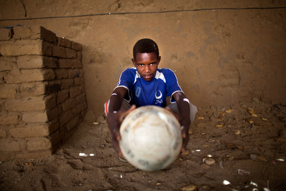
Alfateh is fourteen years old and originally from Korma, but has been displaced for more than ten years, living in the Abu Shouk camp for internally displaced persons (IDPs) in North Darfur. His passion is football (soccer) and his favorite team is the Al Hilal Club (he is wearing the team's official shirt), based out of Omdurman, across the river from the capital city of Khartoum.
11 June 2014
El Sereif, North Darfur

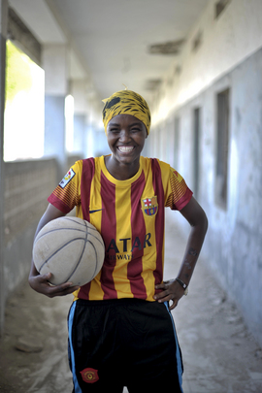
A young Somali girl poses with a basketball during a practice session in Mogadishu. The extremist group Al-Shabaab had targeted women playing sports including basketball, but the sport is making a resurgence in Mogadishu. Today, at least a dozen teams in the city play in a league, and both men and women are coming out to play the sport.
06 June 2013
Mogadishu, Somalia

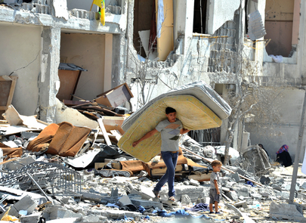
A Palestinian man salvages items from the rubble of his home destroyed by Israeli strikes on a building in northern Gaza Strip.
07 August 2014
Gaza

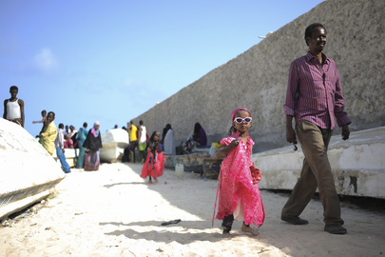

A little girl and her father walk on Lido beach in Mogadishu, Somalia, during Eid al-Fitr, the Muslim holiday marking the end of Ramadan.
28 July 2014
Mogadishu, Somalia

