Color, character, and meaning in Boxers and Saints. Due _____________________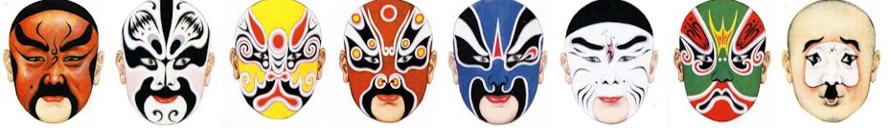
Task: Create a poster with 3-dimensional elements that represents both a traditional Chinese opera mask and a mask that represents you. Create two masks.
Resources: Use the websites that are linked on Mrs. Thomas’ Weebly page.
Requirements:
- One mask representing Chinese opera (you may pick any character that appeals to you)
- One mask representing you
- All art work on a displayable poster board
- 3-dimensional elements attached to the poster board (I will provide you with one 3-D mask)
- Text that explains and labels the elements and colors of both masks
- Text should be typed and printed or created artistically, not just written in marker
- Neat, accurate, colorful, and error-free

